Sri Lanka Institute of Information

Technology



Lab Submission

Lab sheet No 07

**IT24103806**

**Peiris P.V.T.D.**

**IT2120 - Probability and Statistics**

B.Sc. (Hons) in Information Technology

# Exercise 01

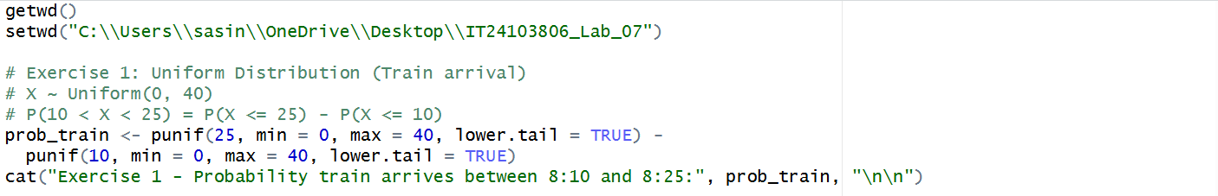

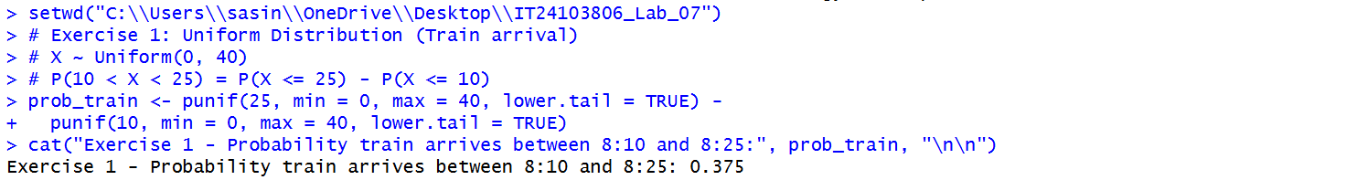

# Exercise 02

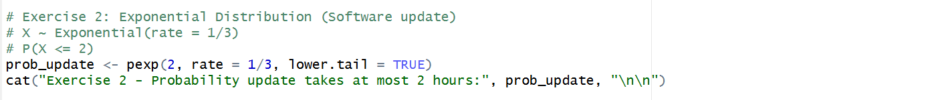

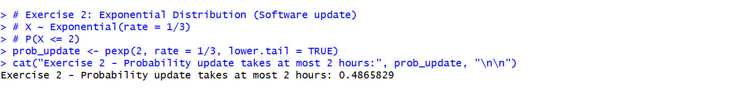

# Exercise 03

